**Doc:** Covid-19 prevention application

**Framework**: angular/Ionic

**Solution**:

1. Acquires user information
2. Creates a heatmap of all user’s location
3. Map gets “hotter” depicting it as safe/unsafe depending on the number of people in each area.

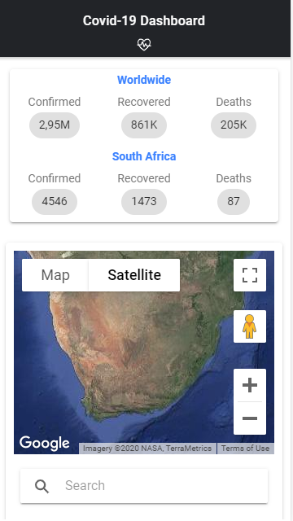

**Purpose**: This is a long-term solution to help prevent the spread of Covid-19. When leaving the house, a user will use this app to check if an area is within the safety range. e.g. 100 people, it will alert the user if the area is safe to venture to.

